The Invasion
of the Ruhr,
January 1923
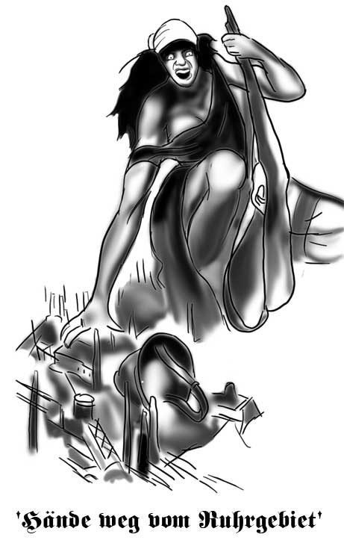

Germany’s economy was in ruins after her defeat in the First World War, and she found the reparations payments (£6,000 million) imposed on her by the allies difficult to meet. Germany did not keep up with her reparations payments, but the French in particular were determined to force Germany to pay what they owed.

In January 1923 French and Belgian troops marched into the Ruhr, the richest industrial area of Germany. German troops were ordered by their government to stand aside to avoid bloodshed and allow the French and Belgians to occupy the area. The French and Belgians took over all of the area’s factories and coal mines. Goods and raw materials made by these industries were seized. This action was permitted under the Treaty of Versailles as Germany had fallen behind in her reparation payments.

The invasion of the Ruhr was a major crisis for the German government and was directly linked to the Treaty of Versailles as the invasion was as a direct result of the German government’s inability to pay reparations (compensation) to the Allies as agreed in 1919. The German public were furious, especially when stories and rumours were told of French atrocities in the area. The Weimar government could do little to stop the invasion and occupation however, as they had a greatly weakened army due to the Treaty of Versailles and were in no position to confront the Allied Powers again. The old myth of the ‘Stab in the Back’ (where the government were accused of deliberately stopping the Great War and surrendering to the Allies although the German troops could have fought on) was once again rekindled. The Weimar Government appeared weak and willing once again to give in to Germany’s ‘enemies’.

The German workers in the Ruhr responded to the invasion with a policy of passive resistance – simply refusing to work. Across Germany there was great admiration for the action of the Ruhr workers. However, their actions only worsened the government’s plight. The workers still had to be paid, even though they were not working or producing goods that would have benefited the nation’s troubled economy.

This was the final straw for the battered German economy, hyperinflation being the result.
Q) Explain why French and Belgian troops invaded and occupied the Ruhr in 1923. (4)

Hyperinflation in the Weimar Republic, 1923

After the First World War, Germany’s economy was devastated.

- Think! Make a spider diagram of the reasons why Germany’s economy would have been devastated by the war.

As a result of this expensive war, Germany experienced inflation. Inflation is when prices continue to rise and wages do not rise in line with them. This makes it harder for people to afford the goods that are on sale. For example, a loaf of bread in Germany cost 0.63 marks in 1918, but by 1922 this had risen to 163 marks. To make matters worse the Treaty of Versailles which had been signed in 1919 demanded reparations payments from Germany. The exact amount that Germany would have to pay was not announced until 1921.
- Germany could not cope with the repayments from this huge reparations bill of
£6,600 million.
- Also, German businessmen had been speculating with German money (buying and selling shares on the stock market), and this made the problem worse.

Discuss:
a) What problems would the Weimar Government have finding the money to make
reparations payments to the Allies?
b) How could the government raise money?
c) What would happen to the government if they did not make reparations payments?

It was as a result of the two points above that Germany experienced HYPERINFLATION. The French and Belgians invaded the Ruhr to take goods ‘in kind’ as Germany had failed to keep her reparations payments. Prices began to rise rapidly within Germany as a result of the government’s decision to print more money to pay for the cost of workers passive resistance in the Ruhr. With more bank notes being introduced into the economy the price of goods began to rise. The more banknotes printed and the higher their value, the more prices rose. In the end banknotes could not be printed fast enough to keep up with those prices.

With more money than there should be in the system the value of money goes down and the price of goods goes up.

The chart below shows the value of the German mark against 1 US dollar from 1922 to November 1923.

Date | Value of mark to £1
July 1914 | 20 marks
Jan 1919 | 35 marks
Jan 1920 | 256 marks
Jan 1921 | 256 marks
Jan 1922 | 764 marks
Jan 1923 | 71,888 marks
Sept 1923 | 1,413,648
Oct 1923 | 3,954,408,000,000
Nov 1923 | 1,680,800,000,000,000

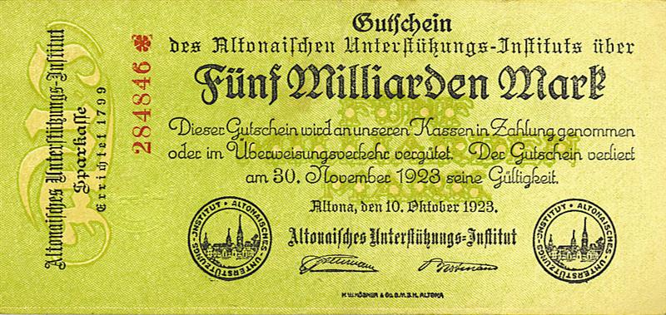
A Five Billion Mark Banknote
from October 1923

Overnight many people’s life savings became worthless and workers found that their wages could not keep up with the rising food prices. Many people became destitute (extremely poor – penniless). It is said that everyone in Germany knew somebody who had suffered. Politicians once again appeared weak and divided as they argued over how to best sort out this new crisis.

As the value of the mark spiralled out of control the price of ordinary goods increased dramatically. By January 1923 the price of a loaf of bread had already reached 250 marks. As a result of hyperinflation this cost escalated to 3,465 marks in July, 1,512,000 marks in September, and a staggering 201,000,000,000 marks by November.

The majority of the public were furious. Old people living on fixed pensions, or people, who lived on their savings, found that these were now worthless. Ordinary workers found it harder to buy food to buy to feed their families, although their wages and unemployment benefit rose dramatically in an attempt to counteract the rising prices and the devaluation of the Mark.

The richest in society, who had not just money in the bank, but land, possessions and investment in foreign currency, were also protected.

These wealthier members of often had foreign bank accounts and could always sell off some of their business interest and possessions. Similarly the more wealthy businessmen could even afford to buy up smaller business ventures that had gone bankrupt. As long as they could afford to see out the period of hyperinflation using their cash reserves they stood to make a profit in future years when the economy stabilised.

The Lower Classes also had less than most to lose – although for a different reason – they had very little money in the first place. The farmers too and those that lived in the countryside were also in a different position to those in the towns and cities. They could grow and eat their own food and slaughter their own animals for food.

The class who suffered the most were the middle class, whose money was largely invested in banks. These people had worked hard to put savings into the bank and many had started small businesses in the hope that they would grow larger and more profitable over time. These savings were now wiped out and their businesses destroyed.

Source 1

From a woman who worked in a Christian centre, helping the poor

The widow of a policeman was left with four children. She had been awarded three months of her late husband’s salary. By the time she received it the amount was only enough to buy three boxes of matches.

Source 2

The memories of a German writer

One day I dropped into a café to have a coffee. As I went in I noticed the price was 5,000 marks – just about what I had in my pocket. I sat down, read my paper, drank my coffee, and spent altogether about one hour in the café, and then asked for the bill. The waiter duly presented me with a bill for 8,000 marks. ‘Why 8,000 marks?’ I asked. The mark had dropped in the meantime, I was told. So I gave the waiter all the money I had, and he was generous enough to leave it at that.

Even though not everyone suffered, everyone knew somebody who had suffered, and the crisis was bad enough to make the government appear weak and divided. Until October 1923 the only action the government took was to authorise the printing of more and more monetary notes, to keep up with the enormous price rises. This did not help, in fact it just made the problem worse. Many photographs from the period show children playing with bundles of worthless banknotes, stacking them like building blocks. Images like this could easily be used by parties who were against democracy, such as the Nazi party, to try and turn the public against their government.

The Weimar government had not been all that popular since its creation in 1919 and there had been a number of attempts to overthrow it. The public were desperate for a solution to their economic problems. Some people turned to extremist groups like the Communists or Nationalists in the hope that stronger leadership would be better able to solve the situation. The Nazis, for example, were promising to tear up the Treaty of Versailles and to restore order and prosperity. They also vowed to defend the German public from aggression and to restore German pride.

Occupation | Effect of Hyperinflation
Elderly People

The Lower Class

The Middle Class

The Upper Class

Q) How were people within Germany affected by Hyperinflation?

- How did hyperinflation affect the Weimar Republic? Explain your answer fully.

When did hyperinflation end?

Hyperinflation reached its peak in November 1923. In August a new Chancellor of Germany had been appointed, Gustav Stresemann. Stresemann called for an end to passive resistance in the Ruhr as he could see that the printing of more money to pay striking workers was causing the devaluation of the Mark and prices to spiral out of control. If this trend continued Stresemann realised that Germany would become bankrupt. He also introduced a new ‘temporary’ currency called the Rentenmark in an effort to bring inflation down and stabilise the economy.

Stresemann made sure that old banknotes were recalled and destroyed and Hans Luther, the Finance Minister, issued the new Rentenmark in their place. This meant that the amount of money in circulation was now reduced and limited.

In 1924 when the economy had stabilised sufficiently and with Stresemann now as Foreign Minister, a permanent currency was brought in to replace the Rentenmark . This was called the Reichsmark.

